Speed

November 6**, 2019**

**Table of Contents**

**1.** **EXECUTIVE SUMMARY 3**

1.1 Project Overview 3

1.2 Purpose and Scope of this Specification 3

**2.** **PRODUCT/SERVICE DESCRIPTION 3**

2.1 Product Context 3

2.2 User Characteristics 3

2.3 Assumptions 3

2.4 Constraints 3

2.5 Dependencies 4

**3.** **REQUIREMENTS 4**

3.1 Functional Requirements 5

3.2 Security 5

*3.2.1* *Protection 5*

*3.2.2* *Authorization and Authentication 6*

3.3 Portability 6

**4.** **REQUIREMENTS CONFIRMATION/STAKEHOLDER SIGN-OFF 6**

**5.** **SYSTEM DESIGN 6**

5.1 Algorithm 6

5.2 System Flow 6

5.3 Software 6

5.4 Hardware 6

5.5 Test Plan 7

5.6 Task List/Gantt Chart 7

5.7 Staffing Plan 7

# Executive Summary

## ***Project Overview***

The purpose of this project is to have a robot complete five figure eight loops in the fastest time possible while holding the figure of a figure eight loop.

## ***Purpose and Scope of this Specification***

The purpose of this project is to fulfill the requirements of the assignment and assess our skills to work together as a group and organize our plans within this document. The project tests our proficiency with coding in Python, and determines the skill level of each group member with respect to attributes such as teamwork, problem solving and implementation of subjects learned.

# Product/Service Description

## ***Product Context***

* This is our project for CS-104, for the Sprint 2 Speed section of the robotics project.
* The robot runs on our code created on sphero and a Bluetooth-compatible device(phone).

## ***User Characteristics***

* This program is exclusively used by our group and to be graded by by Professor Eckert

## ***Assumptions***

* The room will be available to test in.
* the room will have an adequate setup allowing the robot to execute code
* The device will be charged.
* The program’s code will work correctly.
* Our devices will function and be able to begin the program
* There will be no malfunction in the robot

## ***Constraints***

* The robot’s short battery life must be kept in mind.
* The robot requires a long charging time.
* The robot’s testing is limited to one classroom, HH 208

# Requirements

|  |  |  |  |  |
| --- | --- | --- | --- | --- |
| **Req#** | **Requirement** | **Comments** | **Priority** | **Date Rvwd** |
| SPD_01 | Code has to be written with optimal results | Code has been written (1st draft) | 1 | 11/8 |
| SPD_02 | Classroom has to be available for testing | Classroom was available for testing | 2 | 11/8 |
| SPD_03 | Device must be fully charged and in optimal condition | Device was fully charged and condition was optimal | 1 | 11/8 |
| SPD_04 | Device must be tested to confirm code’s function | At first, the device achieved only a figure six-like movement, code needs to be adjusted | 1 | 11/8 |
| SPD_05 | Final run- device must be able to make figure eight shape five times. | successful- sphero robot is able to make figure eight after appropriate modifications to code. | 1 | 11/8 |

## ***Security***

### **Protection**

* This code will only be accessible to our group.
* The code on SpheroEDU will be kept private.

# Requirements Confirmation/Stakeholder sign-off

## ***Algorithm***

* Connect your device to the robot, using Sphero software.
* Place your robot at the start of the track.
* Orient your robot correctly.
* Execute program

## ***System Flow***

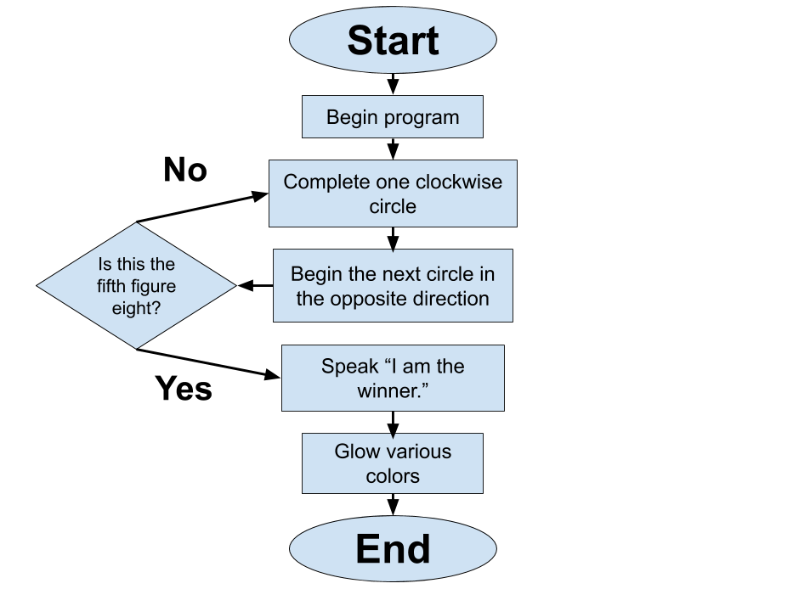

## ***Software***

* This program will be developed using Sphero's software, which is based on the coding language C.

## ***Hardware***

* This program revolves around the use of a computer or smartphone to store the code and run the program. It also requires the robot, of course.

## ***Test Plan***

|  |  |  |  |  |  |
| --- | --- | --- | --- | --- | --- |
| **Reason for Test Case** | **Test Date** | **Expected Output** | **Observed Output** | **Staff Name** | **Pass/Fail** |
| Make the robot go in a circle. | 11/5 | The robot will complete a circle. | It indeed went in a circle. | Adriel | Pass |
| Make the robot complete 1 figure eight loop. | 11/5 | The robot will complete a figure eight. | It went in more of a "figure 6", not desirable. | Adriel | Fail |
| Make the robot complete 1 figure eight loop, with code adjustments | 11/5 | The robot will complete a figure eight. | It completed a true figure eight. | Adriel | Pass |
| Make the robot light up with the appropriate lights. | 11/6 | The robot will light up. | It indeed did light up. | Adriel | Pass |
| Make the robot speak the appropriate phrase | 11/6 | The robot will say its phrase. | It said the phrase we wanted it to. | Adriel | Pass |

## ***Task List/Gantt Chart***

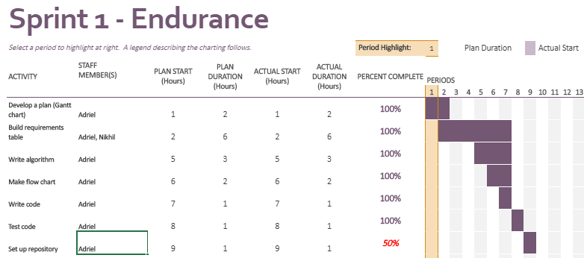

## ***Staffing Plan***

Insert a chart/table that depicts the roles and responsibilities of each team member that worked on this project

|  |  |
| --- | --- |
| **Name** | **Role** |
| Adriel Juarez | Programmer, Writer, Tester |
| Jefrin Rivera | Proofreader |
| Nikhil Ramesh | Writer |